Practical no. 21
Name :- Danish Altaf Solkar Enrolment no. :-24111590805
Class :- CO3K – B Subject :- OOP
Aim :- Define a class parent in which use read function, define another class child use same read function. Display the data of both the read function on output screen using virtual function.
Program :-
#include<iostream.h>
#include<conio.h>
class Parent {
public:
int a, b;
virtual void read() {
cout<<"\n Enter 2 numbers";
cin>>a>>b;
}
};
class Child : public Parent {
public:
void add() {
cout<<"Addition:"<< a + b;
}
};
void main() {
clrscr();
Parent *ptr;
Child c;
ptr = &c;
ptr -> read();
c.add();
getch();
}
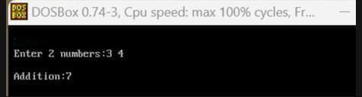
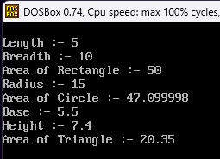
Output :-

